Date: 23.06.2025



Copyright @ 2024 PibyThree.com All Rights Reserved

Simple Web App with Docker

Contents

1. EC2 Instance 2

2. Directory Structure 2

3. Creating the web app and Dockerfile 2

a. app.py 2

b. requirements.txt 2

c. Dockerfile 2

4. Running the web app in Docker Container 3

a. Building the Image 3

b. Running the Container 3

5. Accessing the web app 3

# 1. EC2 Instance

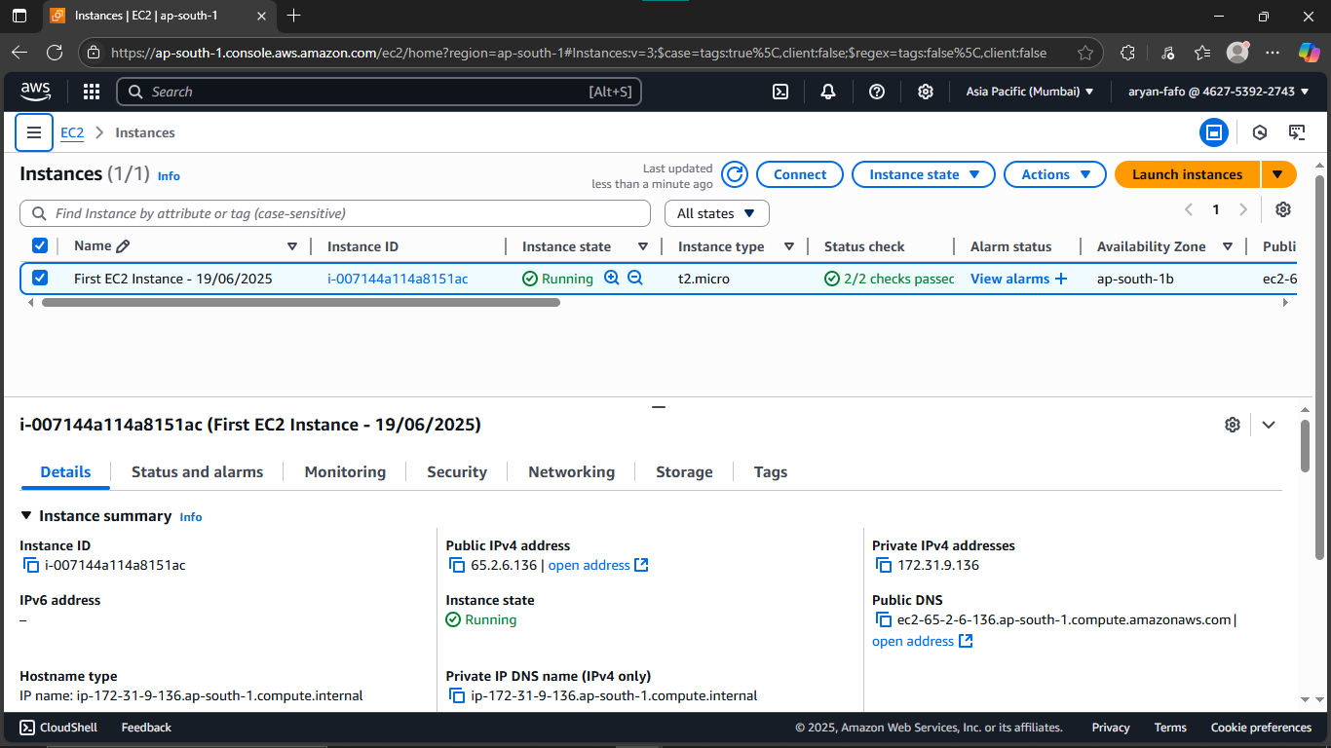

# 2. Directory Structure

|  |
| --- |
| simple-web-app/  |-- app.py  |-- Dockerfile  |-- requirements.txt |

# 3. Creating the web app and Dockerfile

## app.py

|  |
| --- |
| import os  from flask import Flask  app = Flask(__name__)  @app.route("/")  def main():  return "Hello World!"  if __name__ == "__main__":  app.run(debug=True) |

## requirements.txt

|  |
| --- |
| Flask==3.1.1 |

## Dockerfile

|  |
| --- |
| FROM python:3.12  WORKDIR /app  COPY requirements.txt ./  RUN pip3 install -r requirements.txt  COPY . ./  EXPOSE 5000  CMD ["python3", "-m", "flask", "run", "--host=0.0.0.0"] |

# 

# 4. Running the web app in Docker Container

## Building the Image

|  |
| --- |
| sudo docker build -t simple-web-app:v1 . |

## Running the Container

|  |
| --- |
| sudo docker run –d –p 8080:5000 simple-web-app:v1 |

# 5. Accessing the web app

